Performance Per Salary (PPS): A Tool for NFL Front Offices to Evaluate Running Back Spending Against the Cap

Author: Robert Greenberg

The NFL has entered an era where top running backs (RBs) have more power over their contracts than ever before. Todd Gurley’s 2018 contract established new expectations for the money commanded by top-notch NFL RBs, signaling that contract inflation has extended to skill positions beyond quarterbacks. Similarly, Le’Veon Bell’s 2018 season-long strike and Ezekiel Elliot’s 2019 pre-season holdout - and eventual contracts - display the leverage of world-class RBs to an NFL franchise. Why are NFL teams’ General Managers willing to open their wallets to top NFL RBs approaching the end of their rookie deals, when recent rookie RB classes have performed so well (*Figure 1)* and mid-tier free agent classes have been sufficiently productive?Sports Reference’s Approximate Value (AV), Football Outsider’s Defense-Adjusted Yards Above Replacement (DYAR), and Defense-Adjusted Value Over Average (DVOA) are valued statistics to measure player performance, but they fail to factor in the business side of the equation. How can we use these metrics to make better team personnel decisions? Introducing a salary cap element will facilitate a deeper understanding of positional value relative to salary cap allocation and present a logical line of inquiry for evaluating RB’s value to teams. Basic analysis of RB’s DYAR against average annual salary brings into question whether signing an elite RB yields greater value than a rookie or replacement-level free agent.

Using NFL RB data from 2015-2018, I developed a Decision Tree based machine learning classification model to evaluate RBs on-field value compared to their average annual salaries (*Figure 2)*. To do so, I created a variable titled Performance Per Salary (PPS), which compares DYAR and salary for all RBs based on percentile benchmarks, labeled as follows:

* Good value: a player who is paid less than the median salary, but performed above the 75th percentile for their position.
* Fair value: a player who was paid between the 25th and 75th percentile and performed between the 25th and 75th percentile for their position.
* Poor value: a player who was paid more than the median salary, but performed below the 25th percentile for their position.

I performed the same procedures with rookie and free agent RBs to forecast relative PPS’s among these subsets. After training the model, I predicted the PPS labels of all rookies and free agents from the past four years with a score accuracy of 0.795 and 0.810, respectively. The PPS breakdown is as follows: 19.26% constituted good value, 68.87% constituted fair value, and 11.87% constituted poor value.

The PPS model could have an impact on the way teams value RBs and assist in cap space decisions. Ultimately, this research could solve a problem front offices have faced for decades: Should teams pay higher salaries for established talent or could they get better bang for their buck elsewhere? Implementation of similar models for the rest of the skill positions will also be developed.

**[Word Count: 499]**

*Figure 1: Analysis of RB performance (DYAR) vs. Average Annual Value (Salary) grouped by round selected*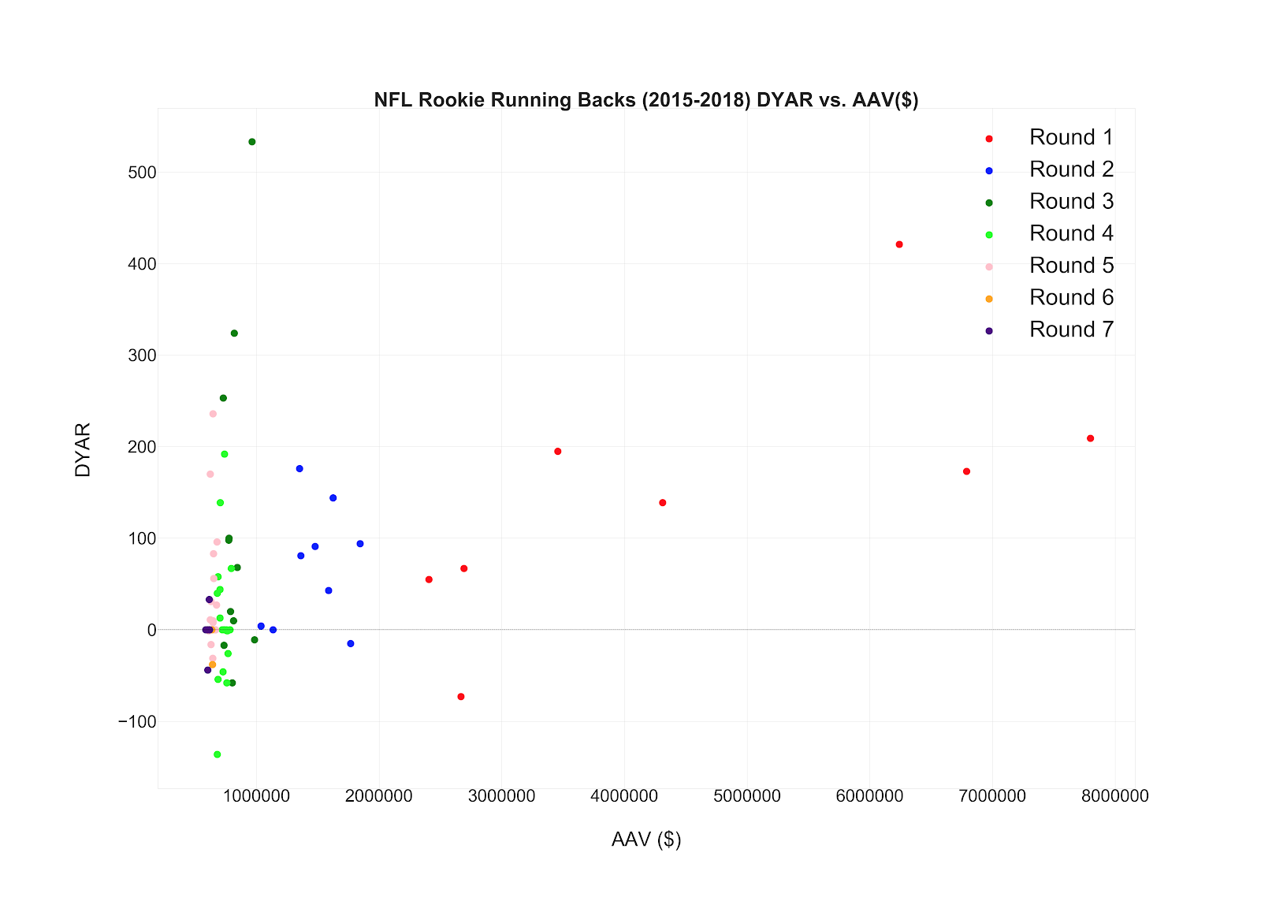

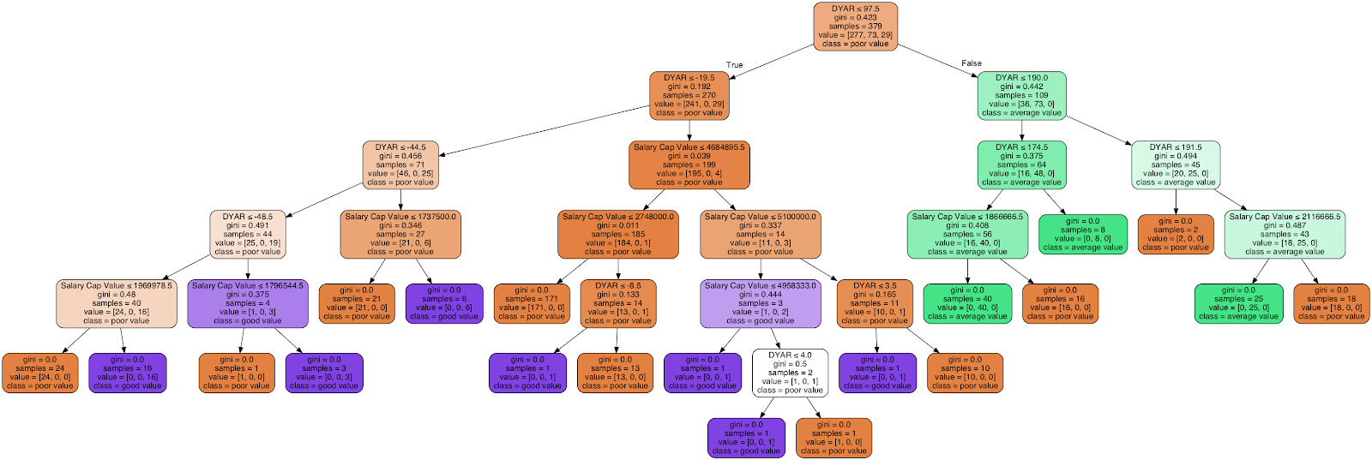*Figure 2: This is a graphic visualization of the model to determine the value of a RB using PPS*